CIRCUITGUARD: Automated PCB Defect Detection and Classification System

1. Abstract
Printed Circuit Boards (PCBs) are the fundamental building blocks of modern electronic devices. They are used in a wide range of applications, from computers and mobile phones to medical instruments and automobiles. PCBs provide both mechanical support and electrical connectivity to various electronic components. Even minor defects on a PCB, such as broken tracks, short circuits, missing holes, or spurious components, can result in significant issues, including device malfunction, safety hazards, or financial losses.
Traditionally, PCB inspection relies on manual visual inspection, which is slow, labor-intensive, and prone to human error. To address these challenges, this project, titled CIRCUITGUARD, proposes an automated system for PCB defect detection and classification using a combination of image processing techniques and deep learning algorithms. The system works by comparing a test PCB image with a defect-free reference template, detecting defect regions, and classifying the defects using a Convolutional Neural Network (EfficientNet-B4).
The system also provides a web-based interface developed using Streamlit, allowing users to upload PCB images and receive annotated outputs with defects highlighted. The proposed model achieves a validation accuracy of over 90%, ensuring reliable and efficient identification of defects. This project demonstrates how automation and deep learning can significantly improve inspection efficiency and accuracy in PCB manufacturing.

2. Introduction
Printed Circuit Boards (PCBs) form the backbone of most electronic circuits. They provide both mechanical support and electrical connections for various components through conductive tracks and pads. However, during the manufacturing process, defects can occur, which may severely compromise the performance and reliability of the final product.
Manual inspection of PCBs is the traditional approach used to detect defects. However, this method has several disadvantages:
- Time-consuming: Inspecting each PCB manually is slow and inefficient.
- Labor-intensive: Skilled personnel are required for careful inspection, increasing operational costs.
- Error-prone: Human inspection is subjective and may miss subtle defects, leading to potential failures in the final product.
Automation of the PCB inspection process addresses these limitations. By leveraging computer vision and deep learning, CIRCUITGUARD provides a fully automated defect detection pipeline that delivers high accuracy and real-time performance. The system not only reduces inspection time but also improves consistency and reliability in defect identification.

3. Problem Statement
The objective of this project is to design and develop an automated PCB defect detection and classification application that meets the following criteria:
- Defect Detection: Identify defective regions by comparing a test PCB with a reference template.
- Defect Localization: Highlight the location of defects using bounding boxes.
- Defect Classification: Classify each defect into predefined categories such as missing hole, short circuit, open circuit, spur, mouse bite, and spurious copper.
- User Interface: Provide an easy-to-use frontend interface for image uploads and download of annotated results.
This approach aims to combine image processing techniques with deep learning-based classification to deliver a complete end-to-end solution for PCB inspection.

4. Objectives
The key objectives of CIRCUITGUARD are as follows:
- Automation: Automate the PCB defect detection and classification process, reducing dependency on manual inspection.
- Accurate Classification: Accurately classify defects into predefined categories, minimizing false positives and negatives.
- End-to-End System Development: Integrate both frontend and backend components to provide a complete solution for PCB inspection.
- High Accuracy: Leverage the EfficientNet-B4 CNN model to achieve high classification accuracy on defective regions.
- Real-Time Performance: Ensure the system provides fast processing and user-friendly output visualization.

5. Dataset Description
The system uses the DeepPCB Benchmark Dataset, which is widely adopted for PCB inspection research. The dataset provides paired images consisting of a defect-free reference template and a corresponding defective PCB sample, along with annotation files describing defect locations.
Dataset Details:
- Total Images: 693
- Defect Types and Counts:
  - Missing Hole: 115
  - Mouse Bite: 115
  - Open Circuit: 116
  - Short Circuit: 116
  - Spur: 115
  - Spurious Copper: 116
Each sample in the dataset includes:
- The defective PCB image
- The corresponding defect-free reference image
- Annotation files describing the defect location and type
This dataset enables training and evaluation of the system in both defect localization and classification tasks.

6. System Workflow
The workflow of CIRCUITGUARD can be divided into several key stages:
- Image Subtraction: The test PCB image is compared with the reference image to highlight areas of difference, which are potential defect regions.
- ROI Extraction: Regions of Interest (ROIs) containing possible defects are extracted for further analysis.
- Contour Detection: Defect boundaries are detected, and bounding boxes are drawn to localize the defects.
- Model Training: Extracted defect ROIs are used to train the EfficientNet-B4 model for defect classification.
- Prediction and Annotation: During testing, the system predicts defect types and annotates the PCB image with bounding boxes and labels.
- Frontend Interface: A Streamlit web application allows users to upload PCB images, view annotated results, and download reports.
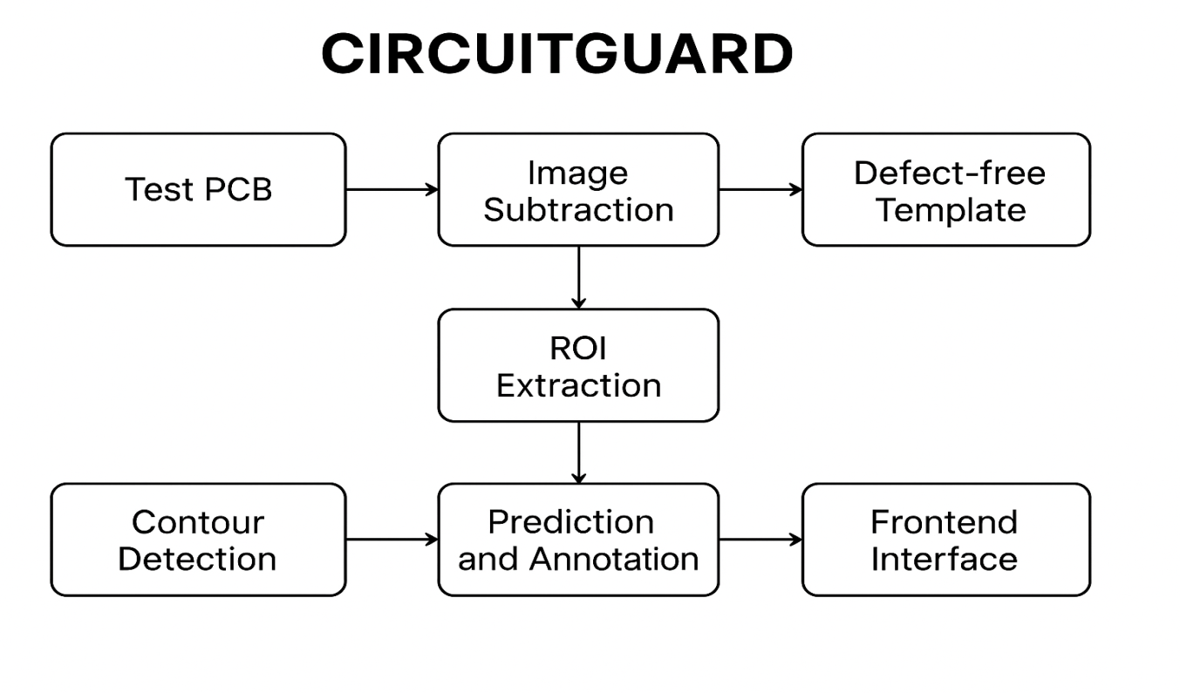

7. Image Processing
Image processing is a critical component of the CIRCUITGUARD system. The process isolates defective areas to provide efficient input for the CNN classifier.
Tools Used:
- OpenCV (Python)
Processing Steps:
- Grayscale Conversion: Convert images to grayscale to simplify processing.
- Image Subtraction: Subtract the reference image from the test PCB to highlight differences.
- Contour Detection: Detect contours to localize defect regions.
- ROI Cropping: Extract bounding boxes containing defects as input for CNN classification.
This pipeline ensures that only defective regions are analyzed, improving training efficiency and classification accuracy.

8. Model Training and Classification
Model Used: EfficientNet-B4 (PyTorch, pretrained on ImageNet)
Dataset Preprocessing:
- Input size: 128 × 128 pixels (cropped ROIs)
- Data augmentation and normalization applied
- Train/validation split: 80/20
Training Setup:
- Optimizer: AdamW
- Loss Function: Cross-Entropy with label smoothing
- Learning Rate Scheduler: Cosine Annealing
- Mixed Precision Training for computational efficiency
- Early Stopping: Patience = 5 epochs
- Maximum Epochs: 50
Results:
- Validation Accuracy: ≥ 90%
- Stable convergence observed with minimal overfitting
- Confusion matrix and accuracy/loss plots demonstrate model performance

9. Frontend and Backend Integration
Frontend:
- Developed using Streamlit for simplicity and interactivity
- Features:
  - Upload section for template and test PCB images
  - Display annotated outputs with bounding boxes and defect labels
  - Download options for annotated images and CSV logs
- Designed for non-technical users with a clean and intuitive interface
Backend:
- Implemented in Python using OpenCV and PyTorch
- Handles image processing, ROI extraction, and inference
- Provides predictions per image, suitable for real-time inspection

10. Results and Evaluation
Defect Detection:
- Defects are accurately localized using contour-based bounding boxes.
Classification:
- The CNN model achieves >90% accuracy, with minimal false detections.
Performance:
- Average processing time: around 7 seconds per image
- Reliable and consistent predictions across different defect types
Outputs:
- Annotated PCB images with bounding boxes, defect labels, and confidence scores
- Downloadable defect reports including images and CSV logs

11. Conclusion
CIRCUITGUARD successfully automates the PCB defect detection and classification process by integrating image processing techniques with deep learning-based classification. The system accurately identifies defects, classifies them into predefined categories, and provides a user-friendly web interface for interaction. The project demonstrates high accuracy, efficiency, and practical applicability in research and industrial PCB inspection.

12. Future Work
Potential enhancements for CIRCUITGUARD include:
- Extending the dataset to include more PCB types and defect categories
- Integration with cloud platforms for remote inspection and large-scale deployment
- Implementation of real-time inspection capabilities for manufacturing lines
- Optimization for embedded or edge devices to enable on-site PCB testing

